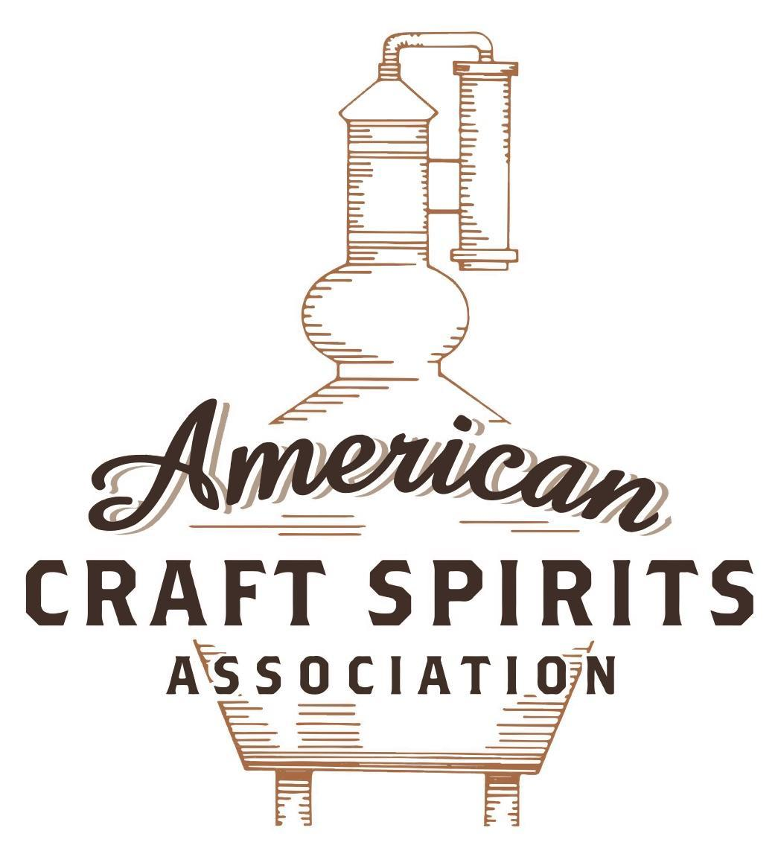
Spirits DtC Shipping Guide

This guide summarizes the direct-to-consumer shipping rules for distilleries in all 50 states and D.C. and also addresses the measures state governments have taken to ease delivery and shipping restrictions during the COVID-19 pandemic.

DtC Quick Guide Comparison

Out-of-State Distilleries  Can Ship Into State? |  |  |  | In-State Distilleries  Can Ship Within State?
State | Yes | No |  | State | Yes | No
AL |  | X |  | AL |  | X
AK | X |  |  | AK | X
AZ | X |  |  | AZ | X
AR |  | X |  | AR |  | X
CA |  | X* |  | CA |  | X*
CO |  | X |  | CO |  | X
CT |  | X* |  | CT |  | X
DE |  | X |  | DE |  | X
DC | X |  |  | DC | X
FL |  | X |  | FL |  | X
GA |  | X |  | GA |  | X
HI |  | X* |  | HI |  | ?*
ID |  | X |  | ID |  | X
IL |  | X* |  | IL |  | X*
IN |  | X |  | IN |  | X
IA |  | X* |  | IA |  | X*
KS |  | X |  | KS |  | X
KY | X |  |  | KY | X
LA |  | X |  | LA |  | X
ME |  | X* |  | ME |  | X*
MD |  | X |  | MD |  | X
MA |  | X |  | MA |  | X
MI |  | X |  | MI |  | X
MN |  | X |  | MN |  | X
MS |  | X |  | MS |  | X
MO |  | X |  | MO |  | X
MT |  | X |  | MT |  | X
NE | X |  |  | NE | X
NV |  | X* |  | NV |  | X
NH | X |  |  | NH |  | X*
NJ |  | X* |  | NJ |  | X*
NM |  | X |  | NM |  | X
NY |  | X* |  | NY |  | X*
NC |  | X |  | NC |  | X
ND | X |  |  | ND | X
OH |  | X |  | OH |  | X
OK |  | X |  | OK |  | X
OR |  | X |  | OR | X
PA |  | X* |  | PA |  | X
RI |  | X* |  | RI |  | X
SC |  | X |  | SC |  | X
SD |  | X |  | SD |  | X
TN |  | X |  | TN |  | X
TX |  | X |  | TX |  | X
UT |  | X |  | UT |  | X
VT |  | X |  | VT |  | X
VA |  | X |  | VA |  | X
WA |  | X* |  | WA | X
WV |  | X* |  | WV |  | X*

WI |  | X |  | WI |  | X
WY |  | X |  | WY |  | X

Notes:
*CA: If passed and signed into law, Senate Bill 620 would allow licensed distilled spirits producers in states other than California and licensed distilled spirits manufacturers or craft distillers in California who obtain distilled spirits direct shipper permits to ship directly to consumers in California
*CT: Consumers with appropriate permit may receive alcohol shipments
*HI: Consumers with appropriate permit may receive alcohol shipments; If passed and signed into law, Senate Bill 65 would allow licensed distilled spirits manufacturers in Hawaii and in states other than Hawaii who obtain direct shipper permits to ship directly to consumers in Hawaii
*IL: If passed and signed into law, Senate Bill 0532 would allow licensed distilled spirits producers in Illinois and in states other than Illinois who obtain distillery shippers’ licenses to ship directly to consumers in Illinois
*IA: If passed and signed into law, House File 639 would allow native distilled spirits manufacturers in Iowa and in states other than Iowa who obtain direct shipper permits to ship directly to consumers in Iowa and to consumers in states other than Iowa
*ME: If passed and signed into law, Legislative Document 1358 would allow distilleries outside of Maine with current manufacturer licenses and distilleries licensed in Maine who obtain spirits direct shipper licenses to ship directly to consumers in Maine
*NJ: (1) If passed and signed into law, Assembly Bill 3167 would allow a craft distillery licensees to ship no more than 9 liters of distilled spirits to a consumer in New Jersey; (2) If passed and signed into law, Senate Bill 3020 would allow craft distillery licensees in New Jersey or in states other than New Jersey to ship no more than 20 liters of distilled spirits to a consumer in New Jersey via common carrier
*NV: Licensed individuals can import one gallon per month of spirits for personal use and the out-of-state supplier must pay excise tax
*NH: If passed and signed into law, Senate Bill 125 would allow licensed liquor manufacturers who obtain direct to consumer shipping permits from the commission to ship directly to consumers in New Hampshire
*NY: Consumer may import up to 90L of liquor per year for personal use without a license; If passed and signed into law, Assembly Bill 3275 would allow licensed liquor manufacturers in states other than New York and licensed distillers and farm distillers in New York to ship no more than thirty-six cases (no more than nine liters per case) of liquor to consumers in New York
*PA: Consumer may place a special liquor order and distiller must ship to a PLCB-operated store
*RI: Distiller can only ship to customer if order was personally placed by customer at distiller's premises
*WA: If passed and signed into law, House Bill 1432 would allow licensed spirits manufacturers in states other than Washington to ship spirits to consumers in Washington
*WV: Distilleries, mini-distilleries, or micro-distilleries licensed in West Virginia or a state other than West Virginia who obtain private direct shipper licenses to ship to a consumer in West Virginia, however the shipments must be made to a retail liquor outlet

MONTANA
Shipment Outbound – Yes (Mont. Code Ann. § 16-4-311(1)).
Shipment Inbound – No, spirits are sold in state agency franchised stores (except for micro-distilleries, see below).
Shipment Intra-state – No, distilleries must sell to the MT Department of Revenue. Microdistilleries may sell liquor that it produces at retail at the distillery directly to the consumer for off-premises consumption if: (i) not more than 1.75 liters a day is sold to an individual; and (ii) the minimum retail price as determined by the department is charged (Mont. Code Ann. § 16- 4-312; ARM 42.13.802(5)(f)).
COVID-19 Measures – The governor’s March 24 directive allowed distilleries to provide delivery, takeout, and drive-up options. Customers may order and pay by telephone or online from a MT manufacturer. Delivery must be conducted by the licensee’s employees over the age of 21 and age of the purchaser and recipient must be verified at the time of delivery. The purchased alcohol must be hand-delivered to the purchaser. This remains in effect until the end of the state of emergency, unless rescinded earlier. The governor lifted Montana’s state of emergency on June 30, 2021. H.B. 226, signed and enacted into law on April 14, 2021, allows a domestic distillery to offer curbside pickup during normal business hours and within 300 feet of the licensed premises, including a drive-through window. Curbside pickup does not include delivery to residences or other businesses. A microdistillery can sell liquor that it produces at retail at the distillery in original packaging between 8 a.m. and 2 a.m. directly to a consumer for off-premises consumption, including curbside pickup subject to the following:
- No more than 1.75 liters of liquor can be sold to a consumer each day
- The minimum retail price determined by the department is charged
Executive Order Rescinding State of Emergency Link: https://governor.mt.gov/EO-10-2021-Rescinding-Emergency-Order.pdf
H.B. 226 Link: https://leg.mt.gov/bills/2021/HB0299/HB0226_X.pdf

Citation (shipment)
Montana Code Annotated
§ 16-4-311. Distillery license. (1) The department may, upon receipt of an application, issue a distillery license to a person who is authorized under the provisions of the Federal Alcohol Administration Act, 27 U.S.C. 201 through 212, to distill, rectify, bottle, and process liquor. A licensee may import, manufacture, distill, rectify, blend, denature, and store spirits of an alcoholic content greater than 0.5% alcohol by volume for sale to the department or as provided in 16-4-312 and may transport the liquor out of this state for sale outside this state. Distillery licensees must be permitted to purchase, from and through the department, alcoholic beverages for blending and manufacturing purposes upon terms and conditions that the department may provide. A licensee may not sell any alcoholic beverage within this state except to the department or as provided in 16-4-312.
Link: https://leg.mt.gov/bills/mca/title_0160/chapter_0040/part_0030/section_0110/0160-0040-0030-0110.html
§ 16-4-312. Domestic distillery. (1) A distillery located in Montana and licensed pursuant to 16-4-311 may:
(a) import necessary products in bulk;
(b) bottle, produce, blend, store, transport, or export liquor that it produces;
(c) perform those operations that are permitted for bonded distillery premises under applicable regulations of the United States department of the treasury.
(2) (a) A distillery that is located in Montana and licensed pursuant to 16-4-311 shall sell liquor to the department under this code, and the department shall include the distillery's liquor as a listed product.
(b) The distillery may use a common carrier for delivery of the liquor to the department.
(c) A distillery that produces liquor within the state under this subsection (2) shall maintain records of all sales and shipments. The distillery shall furnish monthly and other reports concerning quantities and prices of liquor that it ships to the department and other information that the department may determine to be necessary to ensure that distribution of liquor within this state conforms to the requirements of this code.
(3) A microdistillery may:
(a) provide, with or without charge, not more than 2 ounces of liquor that it produces at the microdistillery to consumers for consumption on the premises between 10 a.m. and 8 p.m. A microdistillery may not sell or give more than 2 ounces of liquor to an individual for on-premises consumption during a business day.
(b) sell liquor that it produces at retail at the distillery directly to the consumer for off-premises consumption if:
(i) not more than 1.75 liters a day is sold to an individual; and
(ii) the minimum retail price as determined by the department is charged.
Link: https://leg.mt.gov/bills/mca/title_0160/chapter_0040/part_0030/section_0120/0160-0040-0030-0120.html

Administrative Rules of Montana
42.13.802 DISTILLERY - CONDITIONS FOR OPERATING
(2) A license to operate a distillery is not a retail license.
(4) In addition to all other requirements, a microdistillery that operates a sample room shall:
(a) refrain from providing alcoholic beverages to consumers for on-premises consumption until a sample room is approved by the department;
(b) prevent the consumption or possession of alcoholic beverages outside of an approved sample room and any approved patio/deck;
(c) prevent the consumption or possession of alcoholic beverages on the premises between 8 p.m. and 10 a.m. by removing all alcoholic beverages other than those purchased in original packaging for off-premises consumption from individuals’ possession by 8 p.m.; and
(d) regardless of the liquor product's alcohol content, provide no more than a combined total of 2 ounces of liquor products approved for labeling or exempt from labeling for on-premises consumption to any individual during a business day.
(5) In addition to all other requirements, a microdistillery that conducts off-premises sales shall:
(a) not sell alcoholic beverages through a drive-up window;
(b) sell alcoholic beverages only in original packaging;
(c) sell alcoholic beverages only in an approved sample room;
(d) sell no more than 1.75 liters of liquor product approved for labeling or exempt from labeling in one day to an individual;
(e) sell alcoholic beverages for off-premises consumption only between 8 a.m. and 2 a.m.; and
(f) deliver alcoholic beverages only to the department or an agency liquor store; the delivery of alcoholic beverages to consumers off-site is prohibited.
Link: https://rules.mt.gov/gateway/RuleNo.asp?RN=42%2E13%2E802

The American Craft Spirits Association (ACSA) is working diligently to give our members and industry partners relevant, current updates on statutes and regulations impacting production, sale and distribution of spirits. With the declaration of the novel coronavirus (COVID-19) in early 2020, many states have issued temporary policy changes or longer-term modernization of alcohol beverage laws. State statutes, regulations created by the state alcohol regulatory authority, as well as any other relevant guidance provided by such authorities (such as advisories, opinions, bulletins, etc.) were reviewed in creation of this document. No city or county ordinances were reviewed. Distillers should be aware that even in states where direct shipping is permissible, always remember to avoid shipping to dry counties. Please consult with your state guild or alcohol beverage authority for the most up-to-date information. This content is intended for educational and informational purposes only. ACSA's pro bono law firm of Malkin Law P.A. provided the core content found in this comprehensive overview of the spirits distribution after COVID-19. It was completed in August 2021 and will be updated regularly. If you have updates you would like to provide, please send to legislation@americancraftspirits.org or directly to the law firm at: ryan@malkin.law / malkin.law. Thank you.

